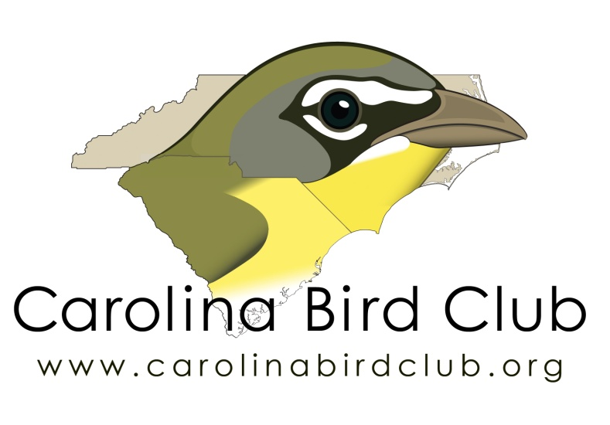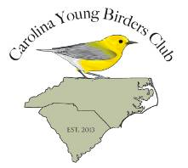
Carolina Bird Club
Scholarship Application Form
Event
Applicant Name: ____________________________________________
Age at date of the event:
Address: _____________________________________________________
_____________________________________________________________
Phone: _______________________________
Cell (optional)__________________________
Email:

Parent or legal guardian
Signature______________________________________________________

Applicant
Signature: _____________________________________________________

Event Information:
Name and location of Event: _______________________________________
______________________________________________________________

Event Start Date:
Sponsoring organization for the event__________________________________
Have you applied or registered for this event: Y______ N______
Have you been selected to attend this event: Y_____ N_____
I am on a waiting list: Y_____ N____
I am willing to present my essay at a seasonal CBC meeting: Y______N_____
I will submit an essay for the CBC Newsletter or Chat: Y_____N______

Carolina Bird Club
Scholarship Application Form
Event

Please select from the options listed below and submit a short essay of no more than 750 words:
Essay Option 1
Describe a memorable birding experience and how it changed your thoughts, ideas, or outlook?
Essay Option 2
What is birding to you and how has it changed your world?
In addition, applicants are welcome to submit letters of endorsement; either from teachers or adult birding mentors, affirming the applicant’s commitment to birds and birding.

We look forward to receiving your application!

